<http://www.wqow.com/story/35719772/eau-claire-leaders-dedicate-chippewa-river-water-trail>

*By Clint Berge, Reporter*

[**CONNECT**](http://www.wqow.com/story/35719772/eau-claire-leaders-dedicate-chippewa-river-water-trail)

*Posted: Jun 21, 2017 4:33 PM CDT*

[[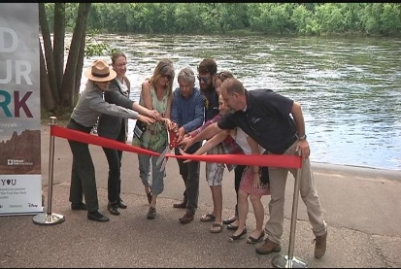](http://wqow.images.worldnow.com/images/14198445_G.jpg)](http://wqow.images.worldnow.com/images/14198445_G.jpg" \o ")

**Eau Claire (WQOW)** - Summer is officially here, which means many of us will be heading toward the water, including the Chippewa River to cool off and enjoy the natural beauty in the city of clear water.  
  
Wednesday was the announcement of a new honor, designating a four mile stretch of the Chippewa River from Hobbs Landing to Phoenix Park as "The Chippewa River Water Trail".  
  
It will give city leaders even more of an opportunity to promote recreation on the river through national programs and helps outdoor enthusiasts learn about the river through online resources and brochures that will be released. The goal is also to spread safety awareness.  
  
"We want to get people to and from the river safely," said Lisa Aspenson, a committee member with the Chippewa River Water Trail. "This application was part of that to make sure we have throughout our whole water trail access points in and out to get people in the river as well as out of the river."  
  
City leaders said Eau Claire was founded because of the river, and to this day, water helps bring visitors to our area.