www.outdoorproject.com

LAST UPDATED: 09/06/2016 - 2:17pm © The Outdoor Project LLC NOTE: Content specified is from time of PDF creation. Please check website for up-to-date information or for changes. Maps are illustrative in nature and should be used for reference only.

Lewis and Clark Discovery Trail, Southwest Washington

Coast, Washington, US

Adventure Description

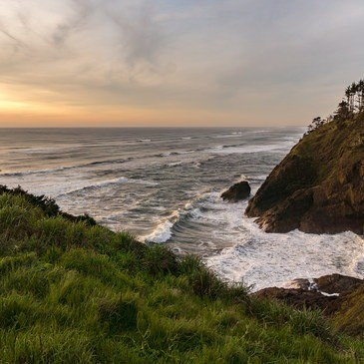

Aden Williamson | 04.17.16

by Aden Williamson | 04/17/2016

The Discovery Trail is an 8.5-mile mostly paved traverse through forest, wetland and coastal dunes that celebrates the Lewis and Clark Expedition's arrival in 1805. While the postcard scenery and quality trail provide reason enough to explore the Discovery Trail, it has more to offer. Along the route you will find numerous discovery stations that give insight into the natural and human history of the region. More than just interpretive signs, the stations also showcase local artwork, artifacts from the Lewis and Clark Expedition, and a whale skeleton, to name a few. Between the natural beauty, the historical significance, the [lighthouse views](https://www.outdoorproject.com/adventures/washington/hikes/cape-disappointment-lighthouse), and the fresh air and exercise, the developers have created something to be proud of.

The main entrance to the trail is on Second Ave SW in Ilwaco.

However, there are many access points along the way (North 26th, Bolstad or Syd Snyder streets in Long Beach, 38th Street in Seaview, Beard's Hollow in [Cape Disappointment State Park](https://www.outdoorproject.com/adventures/washington/parks-wilderness/cape-disappointment-state-park) , and others). Most of the entrances have bike racks, trash cans, bathrooms and picnic tables. From Ilwaco to Beard's Hollow there is more elevation change and some gravel trail as you pass through the forest. As you leave the state park, the trail winds through the lightly rolling dunes just beyond the beach. If you are riding a bike, the twists and turns of the northern half of the trail are sure to put a smile on your face.



# Highlights

Near the trailhead in Ilwaco you have the opportunity to rent

CONGESTION: Moderate bicycles during high season if you don't have your own (inquire

PETS ALLOWED: Allowed locally for more details). Keep in mind that if you enter the trail

NET ELEVATION GAIN: 150.00 ft (45.72 m) from Cape Disappointment, you will need a Washington

Discover Pass.

PARKING PASS: Washington Discovery Pass

PREFERABLE SEASON(S): Winter Getting there (from Portland, OR):

SUITABLE FOR: Hiking - Take US-26 W for about 75 miles

TRAIL DIFFICULTY: Green - Merge onto US-101 N for 19 miles

* Stay on US-101 N to cross the Astoria-Megler Bridge

TOTAL DISTANCE: 8.50 mi (13.68 km) - Continue on US-101 N about 15 miles to Ilwaco WA

TRAIL TYPE: Shuttle - In Ilwaco US-101 N / Spruce St E becomes Spruce St W

* After on block on Spruce St W turn left onto Second Ave SW

TRAILHEAD ELEVATION: 15.00 ft (4.57 m) - Continue two blocks to the intersection with Main St SW

* The Discover Trail entrance is on the right

[Powered by TCPDF (www.tcpdf.org)](http://www.tcpdf.org/)